FILE MEMORANDUM F/NWR-5
DATE: 7/31/2014
FROM: Trevor Conder NOAA Fisheries
TO: File
SUBJECT: Lower Granite Dam adult sockeye fallback/reascension count correction 2014
Introduction
High fallback rates of adult sockeye salmon at Lower Granite Dam have been documented in recent years. Crozier et al. (2014) reports that the fallback rate was highest in 2012 at 49.2%, and was 48.4% in 2013. These researchers conclude that fallback rates increase and conversion rates decline with increasing temperature. Adult fallback is a concern because of substantial implications to adult conversion and survival. Fallback and reascension can also influence management decisions by inflating adult counts as individual fish can be counted multiple times. We briefly investigated the PIT data in season in 2014 and found that high fallback rates were occurring, and sockeye counts are being overestimated in 2014.
Method
We uploaded all PIT detection histories of sockeye salmon detected in the Lower Granite ladder from the start of the sockeye migration until 7/28/2014. We observed all detection histories of each tag code to determine the ratio of fish that fell back and reascended to those that did not fallback. We then applied this ratio to adult counts to estimate the number of over-counts and individual passage. This analysis assumes sockeye with PIT tags fallback at similar rates to untagged fish.
There are four sequential weirs wired with PIT antennas in the upper section of the Lower Granite Dam fish ladder. Antennas 1 and 2 are attached to the upstream most weir at elevation 733, antennas 3 and 4 correspond to the second most upstream weir at elevation 732, antennas 5 and 6 correspond to the second most downstream weir at elevation 731, and antennas 7 and 8 correspond to the most downstream weir at elevation 730. Upstream migrating adults must pass through antennas 7 or 8 first and then pass antennas in descending order as they exit the ladder (Figure 1). The count window is downstream of the PIT antennas. Antennas in the adult trap were ignored in this analysis since detection is only possible when the trap is operated. Trap operation was not continuous throughout the run.
Fallback/reascension criteria
A fish meets our fallback/reascension criteria if it is detected at weir 733 nearest the ladder exit on antennas 1 or 2 with the next detection at the downstream most weir 730 on antennas 7 or 8. An additional criterion was that fish had to take longer than 6hrs. between the 733 and 730 detection to account for the rare chance that a fish swam downstream through both two antennas undetected.

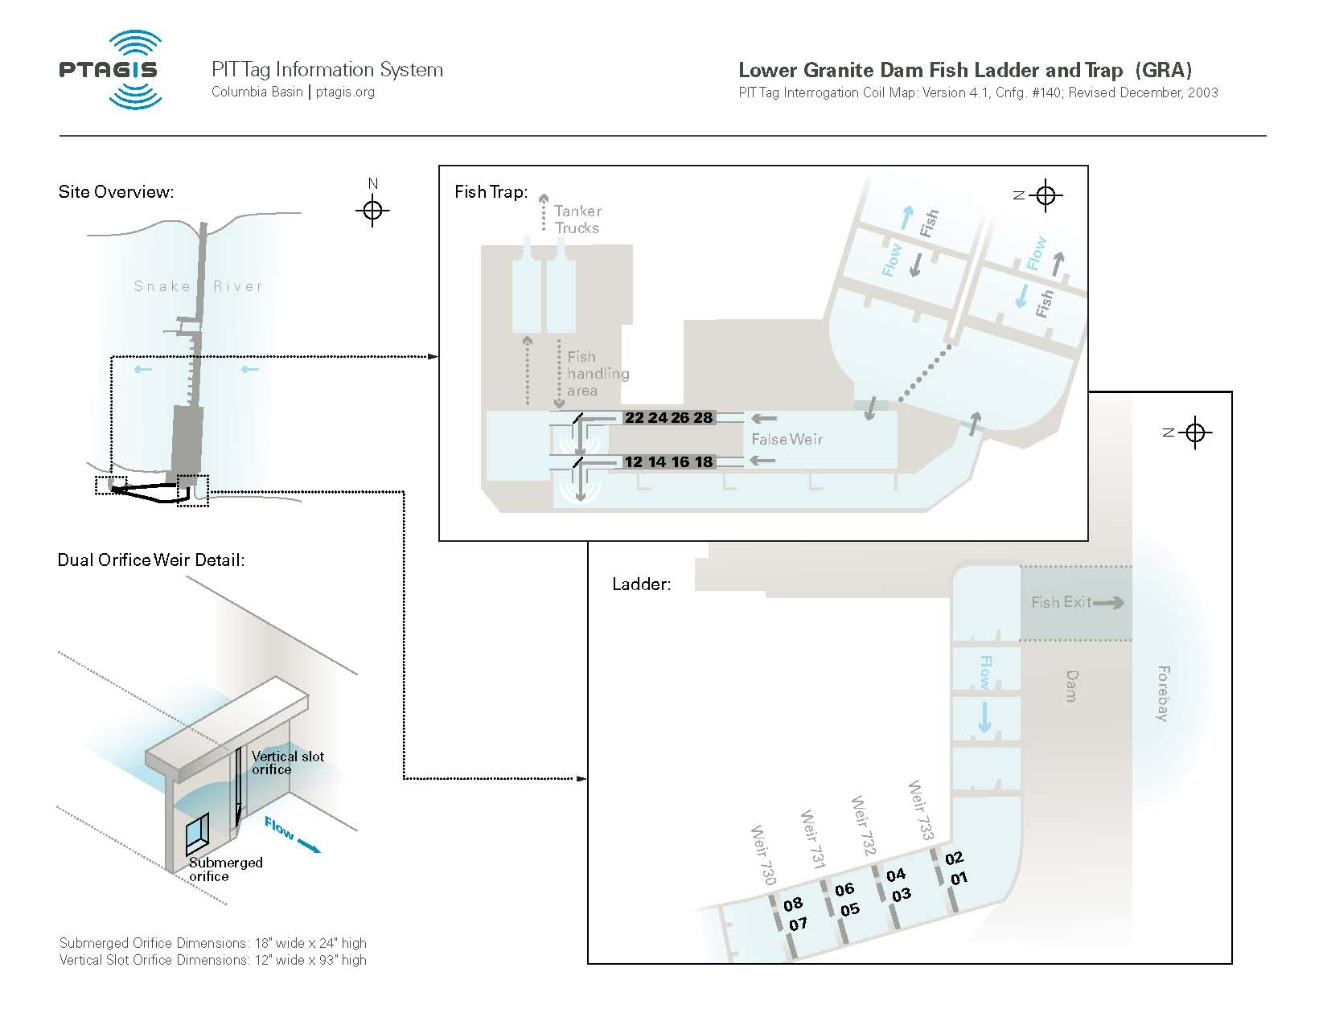
Figure 1. Lower Granite Dam Adult ladder PIT antenna configuration (PTAGIS 2014).
Results
As of July 28th 2014, 196 unique PIT tagged adult sockeye have been detected and estimated to ascend the weirs 730- 733 in the Lower Granite Dam adult ladder. A total of 49 of these ascending fish met the criteria for fallback and reascended at least one time. Several fish reascended more than once leading to a total of 57 fallback/reascension events. One fish fell back through the bypass and reascended; another fish fell back through the bypass and never reascended. Based on this information, we estimate that the total fallback/reascension rate at LGR was 57/196 = 29%. It is likely that this is an underestimate of actual fallback since not all fallbacks reascend. To date, 2500 adult sockeye have been counted at LGR (Figure 2). Applying the fallback reascension rate to the total daily count yields an estimated 1938 unique fish ascending that ladder as of 7/28.
Total counts = unique fish + (unique * reascension rate)
2500 = Unique fish + (Unique fish * .29)
Unique fish = 2500/1.29
Unique fish = 1938

7/24/2014 | 210 | 148 | 62 | 291 | 125 | 166 | 0 | 0 | 0 | 74 | 0 | 0
7/25/2014 | 249 | 187 | 62 | 285 | 121 | 164 | 0 | 0 | 0 | 60 | 0 | 0
7/26/2014 | 163 | 119 | 44 | 302 | 122 | 180 | 0 | 0 | 0 | 68 | 0 | 0
7/27/2014 | 94 | 54 | 40 | 283 | 114 | 169 | 0 | 0 | 0 | 58 | 0 | 0
7/28/2014 | 68 | 38 | 30 | 239 | 96 | 143 | 0 | 0 | 0 | 44 | 0 | 0
total | 112462 | 91906 | 20556 | 4604 | 2085 | 2519 | 0 | 0 | 0 | 2500 | 0 | 0
Date | All Chinook | Adult Chinook | Jack Chinook | All Steelhead | Clipped Steelhead | Unclipped Steelhead | All Coho | Adult Coho | Jack Coho | Sockeye | Chum | Pink
Figure 2. LGR Sockeye counts as of 7/28/2014 (USACOE Fish Data 2014).
Example of non-reascension passage
384.3B239ABD38 | GRA - Lower Granite Dam Adult | 7/17/2014 10:26 | 7 | WEIR 730
384.3B239ABD38 | GRA - Lower Granite Dam Adult | 7/17/2014 10:27 | 5 | WEIR 731
384.3B239ABD38 | GRA - Lower Granite Dam Adult | 7/17/2014 10:27 | 5 | WEIR 731
384.3B239ABD38 | GRA - Lower Granite Dam Adult | 7/17/2014 10:28 | 3 | WEIR 732
384.3B239ABD38 | GRA - Lower Granite Dam Adult | 7/17/2014 10:28 | 3 | WEIR 732
384.3B239ABD38 | GRA - Lower Granite Dam Adult | 7/17/2014 10:29 | 1 | WEIR 733
384.3B239ABD38 | GRA - Lower Granite Dam Adult | 7/17/2014 10:29 | 1 | WEIR 733

Example of fallback/reascension passage (Grey highlight indicates reascension event)
384.3B239A3D2E | GRA - Lower Granite Dam Adult | 7/13/2014 8:48 | 7 | WEIR 730
384.3B239A3D2E | GRA - Lower Granite Dam Adult | 7/13/2014 8:49 | 5 | WEIR 731
384.3B239A3D2E | GRA - Lower Granite Dam Adult | 7/13/2014 8:49 | 5 | WEIR 731
384.3B239A3D2E | GRA - Lower Granite Dam Adult | 7/13/2014 8:49 | 5 | WEIR 731
384.3B239A3D2E | GRA - Lower Granite Dam Adult | 7/13/2014 8:50 | 3 | WEIR 732
384.3B239A3D2E | GRA - Lower Granite Dam Adult | 7/13/2014 8:50 | 3 | WEIR 732
384.3B239A3D2E | GRA - Lower Granite Dam Adult | 7/13/2014 8:50 | 3 | WEIR 732
384.3B239A3D2E | GRA - Lower Granite Dam Adult | 7/13/2014 8:50 | 3 | WEIR 732
384.3B239A3D2E | GRA - Lower Granite Dam Adult | 7/13/2014 8:51 | 1 | WEIR 733
384.3B239A3D2E | GRA - Lower Granite Dam Adult | 7/13/2014 8:51 | 1 | WEIR 733
384.3B239A3D2E | GRA - Lower Granite Dam Adult | 7/13/2014 11:33 | 2 | WEIR 733
384.3B239A3D2E | GRA - Lower Granite Dam Adult | 7/13/2014 11:33 | 2 | WEIR 733
384.3B239A3D2E | GRA - Lower Granite Dam Adult | 7/13/2014 11:34 | 1 | WEIR 733
384.3B239A3D2E | GRA - Lower Granite Dam Adult | 7/13/2014 11:34 | 1 | WEIR 733
384.3B239A3D2E | GRA - Lower Granite Dam Adult | 7/14/2014 18:23 | 7 | WEIR 730
384.3B239A3D2E | GRA - Lower Granite Dam Adult | 7/14/2014 18:23 | 5 | WEIR 731
384.3B239A3D2E | GRA - Lower Granite Dam Adult | 7/14/2014 18:23 | 5 | WEIR 731
384.3B239A3D2E | GRA - Lower Granite Dam Adult | 7/14/2014 18:24 | 3 | WEIR 732
384.3B239A3D2E | GRA - Lower Granite Dam Adult | 7/14/2014 18:24 | 3 | WEIR 732
384.3B239A3D2E | GRA - Lower Granite Dam Adult | 7/14/2014 18:25 | 1 | WEIR 733
384.3B239A3D2E | GRA - Lower Granite Dam Adult | 7/14/2014 18:25 | 1 | WEIR 733

Example Multiple Fallback/Reascension

384.3B239AD0CF | GRA - Lower Granite Dam Adult | 7/21/2014 13:23 | 7 | WEIR 730
384.3B239AD0CF | GRA - Lower Granite Dam Adult | 7/21/2014 13:23 | 6 | WEIR 731
384.3B239AD0CF | GRA - Lower Granite Dam Adult | 7/21/2014 13:23 | 6 | WEIR 731
384.3B239AD0CF | GRA - Lower Granite Dam Adult | 7/21/2014 13:23 | 6 | WEIR 731
384.3B239AD0CF | GRA - Lower Granite Dam Adult | 7/21/2014 13:24 | 4 | WEIR 732
384.3B239AD0CF | GRA - Lower Granite Dam Adult | 7/21/2014 13:24 | 4 | WEIR 732
384.3B239AD0CF | GRA - Lower Granite Dam Adult | 7/21/2014 13:25 | 4 | WEIR 732
384.3B239AD0CF | GRA - Lower Granite Dam Adult | 7/21/2014 13:25 | 4 | WEIR 732
384.3B239AD0CF | GRA - Lower Granite Dam Adult | 7/21/2014 13:26 | 4 | WEIR 732
384.3B239AD0CF | GRA - Lower Granite Dam Adult | 7/21/2014 13:26 | 4 | WEIR 732
384.3B239AD0CF | GRA - Lower Granite Dam Adult | 7/21/2014 13:27 | 4 | WEIR 732
384.3B239AD0CF | GRA - Lower Granite Dam Adult | 7/21/2014 13:27 | 4 | WEIR 732
384.3B239AD0CF | GRA - Lower Granite Dam Adult | 7/21/2014 13:28 | 3 | WEIR 732
384.3B239AD0CF | GRA - Lower Granite Dam Adult | 7/21/2014 13:28 | 3 | WEIR 732
384.3B239AD0CF | GRA - Lower Granite Dam Adult | 7/21/2014 13:28 | 3 | WEIR 732
384.3B239AD0CF | GRA - Lower Granite Dam Adult | 7/21/2014 13:29 | 1 | WEIR 733
384.3B239AD0CF | GRA - Lower Granite Dam Adult | 7/21/2014 13:29 | 1 | WEIR 733
384.3B239AD0CF | GRA - Lower Granite Dam Adult | 7/22/2014 17:31 | 7 | WEIR 730
384.3B239AD0CF | GRA - Lower Granite Dam Adult | 7/22/2014 17:32 | 5 | WEIR 731
384.3B239AD0CF | GRA - Lower Granite Dam Adult | 7/22/2014 17:32 | 5 | WEIR 731
384.3B239AD0CF | GRA - Lower Granite Dam Adult | 7/22/2014 17:32 | 5 | WEIR 731
384.3B239AD0CF | GRA - Lower Granite Dam Adult | 7/22/2014 17:35 | 3 | WEIR 732
384.3B239AD0CF | GRA - Lower Granite Dam Adult | 7/22/2014 17:35 | 3 | WEIR 732
384.3B239AD0CF | GRA - Lower Granite Dam Adult | 7/22/2014 17:35 | 3 | WEIR 732
384.3B239AD0CF | GRA - Lower Granite Dam Adult | 7/22/2014 17:38 | 1 | WEIR 733
384.3B239AD0CF | GRA - Lower Granite Dam Adult | 7/22/2014 17:38 | 1 | WEIR 733
384.3B239AD0CF | GRA - Lower Granite Dam Adult | 7/22/2014 17:38 | 1 | WEIR 733
384.3B239AD0CF | GRA - Lower Granite Dam Adult | 7/24/2014 21:08 | 7 | WEIR 730
384.3B239AD0CF | GRA - Lower Granite Dam Adult | 7/24/2014 21:12 | 5 | WEIR 731
384.3B239AD0CF | GRA - Lower Granite Dam Adult | 7/24/2014 21:12 | 5 | WEIR 731
384.3B239AD0CF | GRA - Lower Granite Dam Adult | 7/24/2014 21:12 | 5 | WEIR 731
384.3B239AD0CF | GRA - Lower Granite Dam Adult | 7/24/2014 21:12 | 5 | WEIR 731
384.3B239AD0CF | GRA - Lower Granite Dam Adult | 7/24/2014 21:13 | 3 | WEIR 732
384.3B239AD0CF | GRA - Lower Granite Dam Adult | 7/24/2014 21:13 | 3 | WEIR 732
384.3B239AD0CF | GRA - Lower Granite Dam Adult | 7/24/2014 21:13 | 1 | WEIR 733
384.3B239AD0CF | GRA - Lower Granite Dam Adult | 7/24/2014 21:13 | 1 | WEIR 733

Multi Day Ladder Movement Non-Reascension

3D9.1C2D6A43BA | GRA - Lower Granite Dam Adult | 7/21/2014 22:25 | 7 | WEIR 730
3D9.1C2D6A43BA | GRA - Lower Granite Dam Adult | 7/21/2014 22:26 | 5 | WEIR 731
3D9.1C2D6A43BA | GRA - Lower Granite Dam Adult | 7/21/2014 22:26 | 5 | WEIR 731
3D9.1C2D6A43BA | GRA - Lower Granite Dam Adult | 7/21/2014 22:29 | 3 | WEIR 732
3D9.1C2D6A43BA | GRA - Lower Granite Dam Adult | 7/21/2014 22:29 | 3 | WEIR 732
3D9.1C2D6A43BA | GRA - Lower Granite Dam Adult | 7/21/2014 22:29 | 1 | WEIR 733
3D9.1C2D6A43BA | GRA - Lower Granite Dam Adult | 7/22/2014 8:01 | 1 | WEIR 733
3D9.1C2D6A43BA | GRA - Lower Granite Dam Adult | 7/22/2014 8:01 | 3 | WEIR 732
3D9.1C2D6A43BA | GRA - Lower Granite Dam Adult | 7/22/2014 8:02 | 5 | WEIR 731
3D9.1C2D6A43BA | GRA - Lower Granite Dam Adult | 7/22/2014 8:02 | 5 | WEIR 731
3D9.1C2D6A43BA | GRA - Lower Granite Dam Adult | 7/22/2014 8:02 | 5 | WEIR 731
3D9.1C2D6A43BA | GRA - Lower Granite Dam Adult | 7/22/2014 8:02 | 5 | WEIR 731
3D9.1C2D6A43BA | GRA - Lower Granite Dam Adult | 7/22/2014 8:02 | 5 | WEIR 731
3D9.1C2D6A43BA | GRA - Lower Granite Dam Adult | 7/22/2014 8:02 | 5 | WEIR 731
3D9.1C2D6A43BA | GRA - Lower Granite Dam Adult | 7/22/2014 8:02 | 5 | WEIR 731
3D9.1C2D6A43BA | GRA - Lower Granite Dam Adult | 7/22/2014 8:02 | 5 | WEIR 731
3D9.1C2D6A43BA | GRA - Lower Granite Dam Adult | 7/22/2014 8:02 | 5 | WEIR 731
3D9.1C2D6A43BA | GRA - Lower Granite Dam Adult | 7/22/2014 8:03 | 7 | WEIR 730
3D9.1C2D6A43BA | GRA - Lower Granite Dam Adult | 7/22/2014 8:38 | 7 | WEIR 730
3D9.1C2D6A43BA | GRA - Lower Granite Dam Adult | 7/22/2014 8:43 | 7 | WEIR 730
3D9.1C2D6A43BA | GRA - Lower Granite Dam Adult | 7/22/2014 8:44 | 5 | WEIR 731
3D9.1C2D6A43BA | GRA - Lower Granite Dam Adult | 7/22/2014 8:44 | 5 | WEIR 731
3D9.1C2D6A43BA | GRA - Lower Granite Dam Adult | 7/22/2014 8:45 | 3 | WEIR 732
3D9.1C2D6A43BA | GRA - Lower Granite Dam Adult | 7/22/2014 8:45 | 3 | WEIR 732
3D9.1C2D6A43BA | GRA - Lower Granite Dam Adult | 7/22/2014 8:46 | 1 | WEIR 733
3D9.1C2D6A43BA | GRA - Lower Granite Dam Adult | 7/22/2014 8:46 | 1 | WEIR 733

References
Crozier, L. G., et al. 2014. Passage and Survival of Adult Snake River Sockeye Salmon within and Upstream from the Federal Columbia River Power System. Report to Walla Walla District U.S. Army Corps of Engineers.

